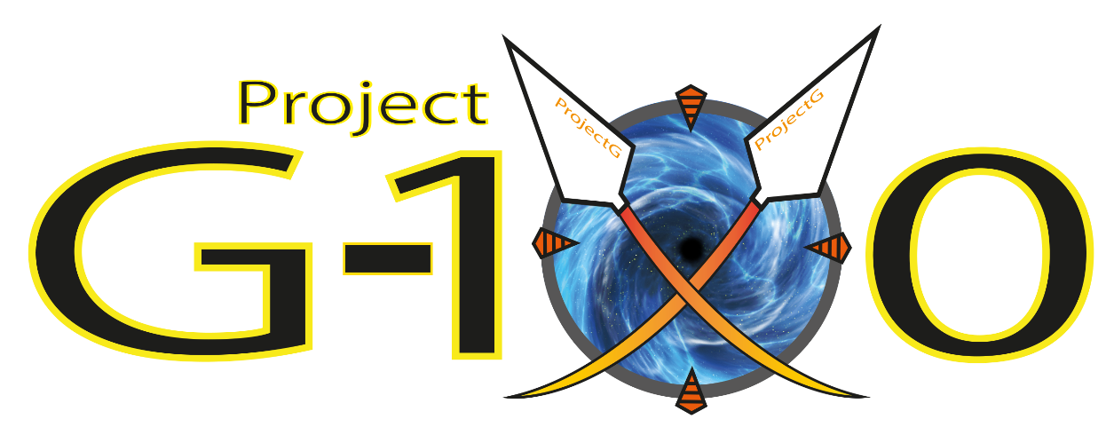

**Design Document for:**



**Group Members:**

**Konrad Dryniewicz – S00160273**

**Daniel Szczodrowski – S00163723**

**Philip D’Arcy – s00164384**

**James Mahady – s00163419**

**Project Supervisor:**

**Neil Gannon**

Table of Contents

Chapter 1 – Project Overview 4

1.1 – Initial Idea 4

Chapter 2 – Goal and Scope 5

2.1 Goal of the Project 5

2.2 Scope of the Project 5

Chapter 3 – Areas of Research 6

3.1 Game Engines 6

3.2 Game Details 7

3.3 Gameplay Style 8

3.4 Maya 9

3.5 Unity Scene Planer 9

3.6 Unity Particle System 9

Chapter 4 – Design & UI 10

4.1 Game Design 10

Engines 11

Power-Ups 11

Enemies 12

4.2 Menu Design 12

4.3 In-Game HUD 16

4.3 World Design 16

4.4 Game Render 17

4.5 Ship Design 18

Chapter 5 – Time Management 22

2.1 Weekly Meetings 22

2.2 Time Distribution 22

Chapter 6 – Problems Encountered 23

6.1 Cleaning out the game 23

6.2 Merging the two versions of game 23

6.3 Maya 23

6.4 Unity scene planner 24

6.5 Unity particle system 24

6.6 Miscommunication 24

Chapter 7 – Results 25

7.1 Levels 25

7.2 Final Game 25

7.3 Models/Assets 25

7.4 Growth 25

Chapter 8 – References & Appendices 26

Bibliography 26

# Chapter 1 – Project Overview

## 1.1 – Initial Idea

Project G100 is a Top-Down "Bullet-Hell" shooter in the same style as Touhou Project and other such games. The aim of the game as the protagonist is to fly your ship through 6 stages and stop The Empire from claiming your home galaxy as theirs. The game will include 3d models with 2d art assets making up the background.

Aided by 3 factions from a galaxy previously occupied by The Empire, (Anaconda Squadron, Cebula Knights, Path of the Scarab) their ships are provided to you for use every time you play. The catch is...You need energy to power the wormhole long enough for them to send these ships over.

This is where we hope to incorporate a loot-crate/gacha system to add ship and power-up customization, similar to Granblue Fantasy.

*“Originally this was a term to describe capsule toys dispensed by Japanese toy machines. The gacha we presently refer to is a virtual luck-based mechanic that works in a similar way: player pays in-game currency to ‘spin’ or ‘roll’ the gacha and receives a random item (character, card, any collectible -- they vary in rarity; the rarest ones usually require extra gacha spins from players who are after them).”* [1]

Enemies and bosses will follow a predictable shooting pattern to allow the player to test their reflexes and muscle memory when dodging attacks. These attacks are to be colourful so that the player can clearly see what they are to avoid during play.

We hope to include a multiplayer "raid" element as well, where several players can tackle the same level to deplete a boss gauge.

# Chapter 2 – Goal and Scope

## 2.1 Goal of the Project

We plan to incorporate the following features into game:

* Stage-Based level progression where Player (as a space ship) progresses through level by destroying any obstacles they face until they reach the final enemy of that level and shoot him until they destroy him. (Each boss will likely have unique parts that will need to be destroyed in order to complete level.)
* Multiple Weapons that player acquires in the game and switch between them during levels.
* Different types of enemies and obstacles that will challenge the player during game.
* Power-Up System that will help player make their ship stronger and help them progress through the game.
* Multiple Level Designs for each level and their level’s bosses.
* Loot-crate/Gacha System to allow player to unlock new ships as well as unlock Power-Up Customization.
* At least three levels, each with their own boss enemy.
* If possible, multiplayer raid type element where multiple players can tackle same boss at once and cooperate or compete against each other.

## Scope of the Project

We plan to focus on shoot ‘em up genre with sci-fi theme. We aim to have six levels with seamless stage progression, where level is split into one long level, four sets of enemies that appear in a pre-set pattern and after those are cleared, player advances onto main enemy in the level, a Boss stage. We also aim to have in-game endless or training mode that player could play through to test out their new power-ups or new weapons or just to practice their skills.

# Chapter 3 – Areas of Research

## 3.1 Game Engines

**Unreal Engine**

Unreal Engine is a highly powerful game engine that allows users to create very detailed and sophisticated games.

***“Unreal Engine 4 is a complete suite of game development tools made by game developers, for game developers. From mobile games to high-fidelity VR experiences to console blockbusters, Unreal Engine 4 gives you everything you need to start, ship, grow and stand out from the crowd.”*** [2]

It focuses mainly on C++ programming language but for those who don’t use that language, Unreal Engine allows user to create games completely in Blueprints.

*“The****Blueprints Visual Scripting****system in Unreal Engine is a complete gameplay scripting system based on the concept of using a node-based interface to create gameplay elements from within Unreal Editor. As with many common scripting languages, it is used to define object-oriented (OO) classes or objects in the engine. As you use UE4, you'll often find that objects defined using Blueprint are colloquially referred to as just ‘Blueprints.’”* [3]

**Unity**

The Unity is a well-developed, great to work with engine that uses C# programming language for scripts, which is ideal as this is the language we’ve been working with for the last two years of college as well as this year. The scripts are used as components and so, by writing universal scripts we can achieve a lot of behavior in a simple manner. Unity as well, offers a clear and simple interface as well as visual 3D world editor which simplifies creation of 3D games. Another helpful feature that Unity 3D consists of is the cross platform export availability. This will allow us to easily create the game not only for PCs but also for mobile devices as well as consoles if we choose to.

*“Unity Technologies offers a platform for creating beautiful and engaging 2D, 3D, VR, and AR games and apps. A powerful graphics engine and full-featured editor enable you to realize your creative vision fast, and deliver your content to virtually any media or device. You can easily connect to your audiences on PCs, consoles, the web, mobile devices, home entertainment systems, embedded systems, or head-mounted displays.”* [4]

## 3.2 Game Details

**Ships**

For the first design draft of the Anaconda Squadron, we looked at different fighter designs from different games and movies. The main features we settled on were that the ships should have a fast and slick design.

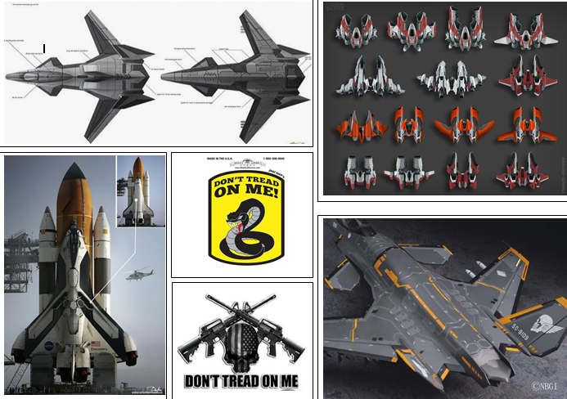

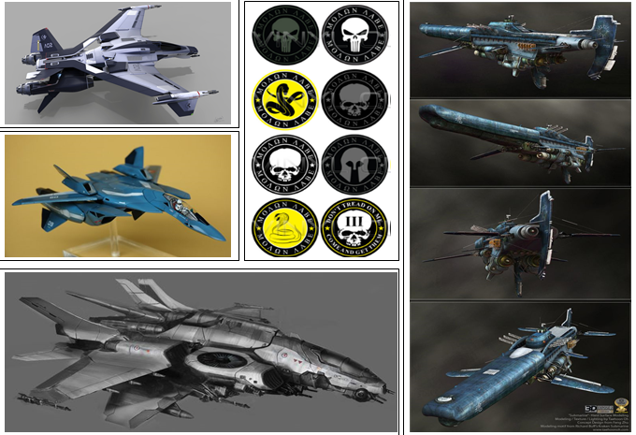

For the first design draft of the Scarabs, we looked at designs from Warhammer 30K and old Spanish Gallons, it was heavily based around the symbol of the scarab beetle. We agreed the Scarab ships should be big, bulky and have a red and gold texture scheme.

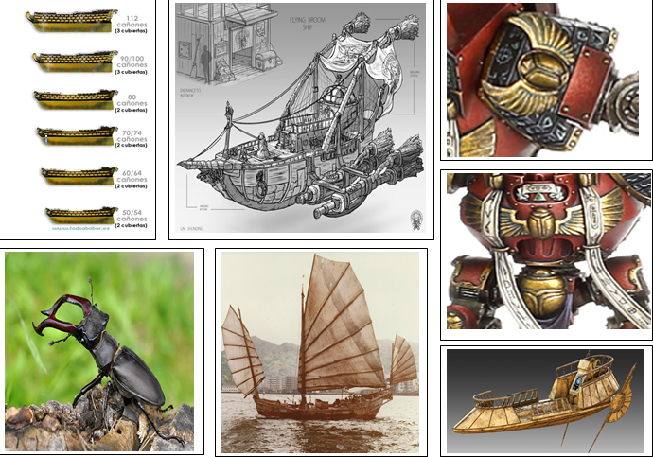

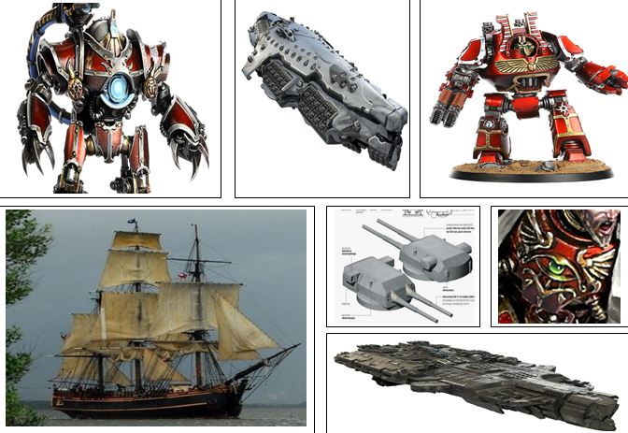

The first design draft for the Cebula were based off of many different ships from a wide range of games and movies. The ships were to be organic in design, this was to try and set the faction apart from the others.

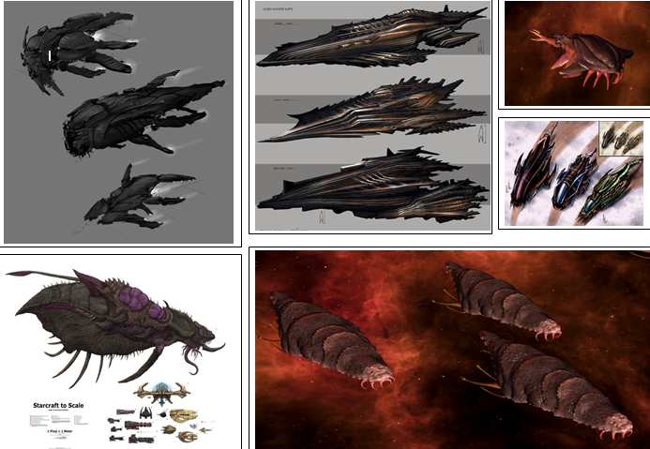

**Game World**

Vandor, the home planet and starting level of the game. The beginning battle is located by the coast of your home base. The location of this level is filled with woods scattered around the level making a forest, and a road that winds through the terrain of the level.

Vandor Orbit. After defeating the first boss and progressing, you are placed in the outer atmosphere of the planet where you come face to face with the might of the Pythis Empire. Here you see Carriers, Motherships & Fighters. In the background, you will see an asteroid field and a massive space satellite.

Solann, the center star of this solar system. Contained on the surface you will see mining constructs, defense cannons, energy transformer, and more as the empire attempts to siphon the energy for their fleet’s hyperspace travel. The player fights the enemies protecting this location. With this being the sun, the lighting has more of a reddish tone.

## 3.3 Gameplay Style

The elements of gameplay we decided on were based on a mixture of this year’s Games Fleadh (Shoot ‘em up) and the character collection element of Japanese “Gacha” mobile games. (Granblue Fantasy shown below).

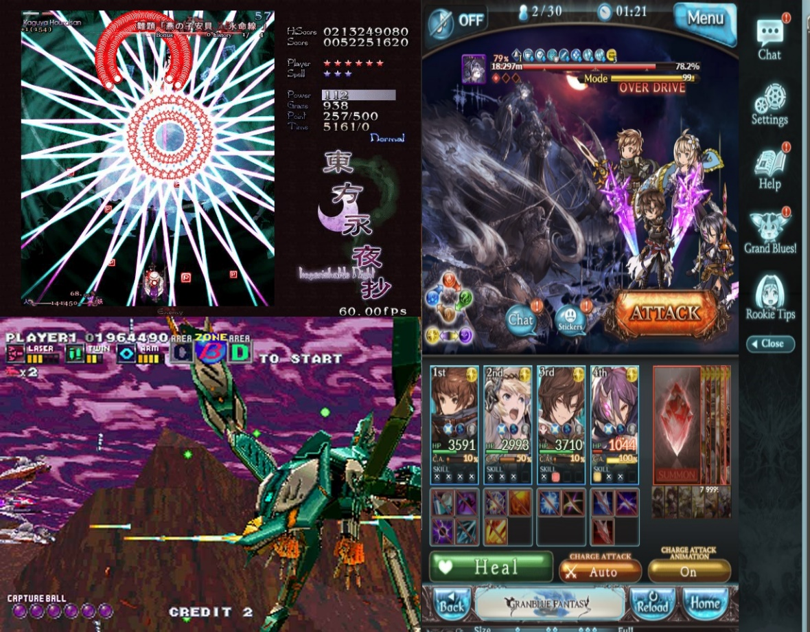To make G100 a fun but challenging experience, we agreed that the type of game we would make would be like titles such as G-Darius and Touhou Project. The former provided us with the idea of a 3D backdrop whilst the latter was the inspiration for some of the bullet patterns present in game.

## 3.4 Maya

Just before we started working on our project we were discussing where will we make 3D models for our game and we decided that Maya was our best choice. First area of research we had done was in second year while working on animation and modelling subject during the year. During our year with Maya we learned a lot, this was the year where we discovered many tools, methods & ways to work with models. We have learned the basics of making simple models up to achieving more advanced and interesting ones, but we still were a mile off from achieving what we have done for our project.

When the third level started, we had decided to broaden our knowledge of using Maya. To do that we decided to learn by ourselves and look up guides on different tools which we had not learned in second year such as: Advanced texturing, Advanced Modelling and expiring files.

While working on the models we have looked up a tutorial how to texture correctly. In this area of research, we looked up an article on Creative Bloq [5] for how to texture in Maya. After reading this article, we learned how to texture models much better. It explained the UV-mapping and other related information. This Article helped us develop much better look on the models.

While working in Maya we needed to learn new ways to make models look better and interesting. As our modelers were well capable of working in Maya the new techniques came naturally thanks to the amount of work that was put in the process of making models. A lot of our research here was messing around with tools as well as experimenting with known tools and trying to develop something new.

After the models were done the next step was to send them to Unity and here we needed to figure out how to do it so we have looked up documentation on unity’s website [6] and thanks to that we figured out a way to export models fully textured to Unity. Neil also played a great part in helping us here.

## 3.5 Unity Scene Planer

While we were working on the game, we needed to develop a scene where the game would take place. For this, we have used the Unity built in scene placement. To do this we simply placed stuff here and there, experimenting with the tool itself and finally due to our research we have developed our own way to work on the levels.

## 3.6 Unity Particle System

While working on the game we ended up at a point where we needed to make particles. Here we were starting with a standard simple particle system and achieving and amazing new effects of portals and electric charges while working on the particles and testing new options / tools.

# Chapter 4 – Design & UI

## 4.1 Game Design

During our first meeting, we have discussed the initial idea for the game, what the game will be about, characters in the game, and overall gameplay. We have organized mood boards for different ships in game. After deciding on engine to use and initial plans, we began work on creating the first version of our game. It featured simple controls, few obstacles, enemy, score system and a first kind of wave system to spawn enemies. This version consisted of many placeholders, which were taken from Unity Default assets to use in the meantime that we were getting models created in.

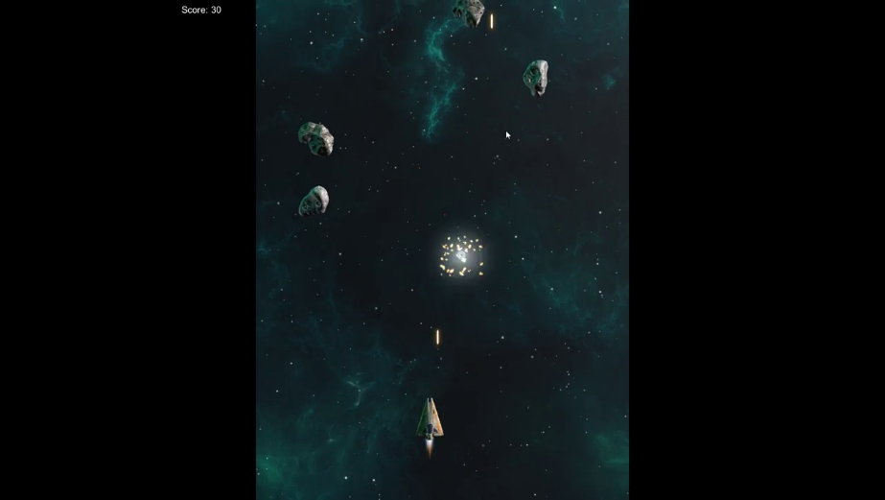

Next, we planned to expand on this version by adding in more features. We wanted to add in a health system, damage system, wave system and a boss for every level and so we concentrated on implementing those features. The health system and damage system were implemented quickly however turned out to be too complex in code and so were re-worked to be simplified. This made them more modular and easy to use on different objects (Player & Enemy/Obstacles/Boss). Next, we focused on Boss and first level Boss. After couple of weeks of hard work, scheduled meetings, constant feedback and good teamwork, those features were implemented and we were well on way to have our first proper version of the game ready for presentation before Christmas break. During the development, we decided we’d change the background from a scrolling 2D texture to a proper 3D animated scenery to give player a more immersive feel while playing the game. We also decided to implement local data storage and a simple menu. The presentation version of the game looked as follows:

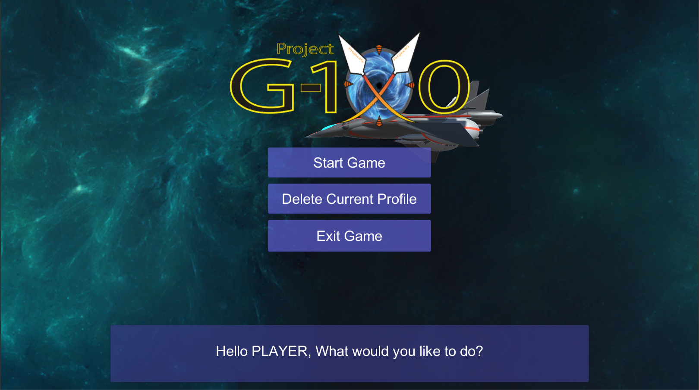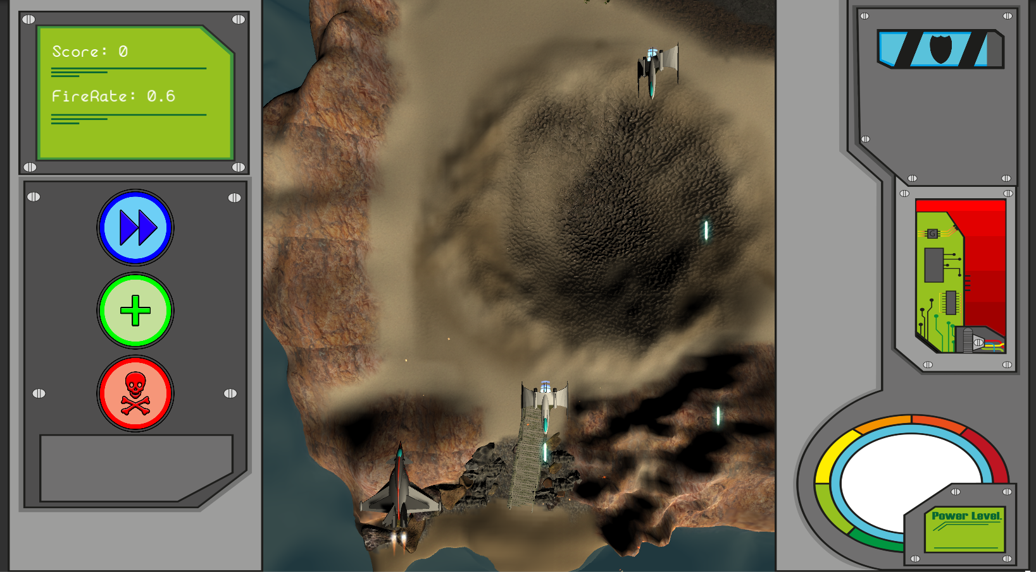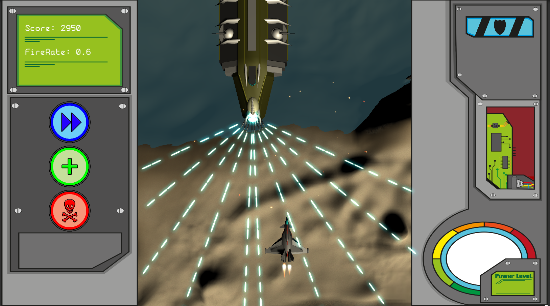

After Christmas, more development followed. We still held scheduled meetings in the same manner as before Christmas. We decided to expand much more on the menu system (More on that below), expand on functionality of HUD system that is in game, implement power-ups that were in presentation for each member of the team. Basically, each member would have their own Power-Up engine named after them, ex. Gannon Cannon, which consisted of three different power-ups that could be picked up in game as well as a special ability for that engine. Gannon Cannon consisted of firerate increase power ups, and its special ability was a large attack speed steroid that would last for only few seconds, giving player stronger DPS when going through waves of enemies. Bit more explanation on those is below:

### Enginesengines

Engines are what drives the gameplay for the player. There are five engines in total in game. From top left going horizontally and then to bottom left and to right, Gannon Cannon, D’Arcy Defense Demolisher, Konrad Cheat-Death Contraption, Mahady Matter Converter and Szczodrowski Strike.

Each engine has its own special ability that is usable after filling in certain amount of energy while going through level and on release gives a different result for each engine. For example, Gannon Cannon increases the player’s attack speed immensely, providing plenty of needed DPS.

### Power-Ups

Each engine consists of three different colored power-ups; a blue, red and green power-up that help the player advance through the level. For each engine, all the power-ups are different. For example, Gannon Cannon Engine consists of Fire Rate up, Fire Rate Up and Attack up power ups that can be picked up after destroying specifically colored enemies that drop them. A power up acts as a temporary boost of the player’s ship’s abilities to help him get through different waves of enemies or through fight with the Boss enemy.

After those were implemented, we focused on getting other levels into the game. Our initial goal was to have six levels, each with their own final boss, however, time wise, that turned out to be impossible so we cut that down to three levels, which was still challenging to implement as each level was set in different space and each boss had their own unique mechanics. We also decided to improve on the HUD and give the Power-up engines a bit of revamp. We have implemented a unique animation system for characters, meaning the character in the new HUD version will react to player’s gameplay. If the player is idle for more than 20 seconds, a special animation is played. If the player is hit, the character will behave based on that, and even more. Each engine features their own character, based on each member of the team.

### Enemies

We tried to add as many unique enemy types as we could manage in order to make each level feel unique.

These were as follows:

* The basic enemy type which would fire at a set rate and fly either left or right randomly.
* Asteroids that the player would have to either shoot or avoid to not be hit.
* Large mines which worked similarly to asteroids except for a shower of bullets once destroyed
* A bomber, which would fly across the screen releasing smaller mines that exploded similar to the ones mentioned before.

As mentioned earlier we also included boss fights at the end of every level to add to the uniqueness of each setting. These were:

* Boss one was a much larger escort ship, which would fire a pattern of bullets before turning to the front and rapid firing in several directions. Players would simply need to dodge between these to defeat him.
* Boss two was a large satellite which required the player to destroy the outer shield generators to open the core to attack. Its defense was an intricate bullet pattern.
* Boss three was a construction platform, tasking the player with destroying a prototype cannon which when destroyed would flip to reveal the true boss; a massive double cannon.

Last stage of development has begun by now. We were implementing the above-named features, polishing off the final bits of game, and ironing out any bugs we still found in game. The Menu was remade into a 3D Hangar with display units placed all over it and camera scrolling through it as the player chose different options. The HUD had much more functionality than when we began and each level had its own wave set, with a boss that had their own unique behavior. The levels were now all fully 3D and were scrolled through slowly with amazing scenery as the player progressed through waves and onto the final boss fight. We also added on a Gacha Lottery System that is show in the menu below. This system will allow player to use in-game earned currency (Crystals), which are calculated with a specific formula based on Difficulty modifier (The better the ship, the less crystals you earn) and enemies killed, to unlock new Power-up engines and new ships to play through the game with.

## 4.2 Menu Design

The menu has gone through many different stages before being finalized. In the beginning, the menu was made to allow player to create profile, that was saved locally, by inputting name, selecting ship and that ship would be saved in the profile for later usage. It also allowed player to delete current profile in case they would want to start the game anew. Both user profile and list of ships were stored locally and loaded in or (if not existing) created from list of objects assigned in the Unity Inspector, meaning the list of ships would always be up to date. Player was only able to use/select from ships that were unlocked in game, otherwise the locked ships would not show up in select. The menu also featured all the ships (That were playable) flying in the background to give it a bit more life. The first menu design looked as follows:

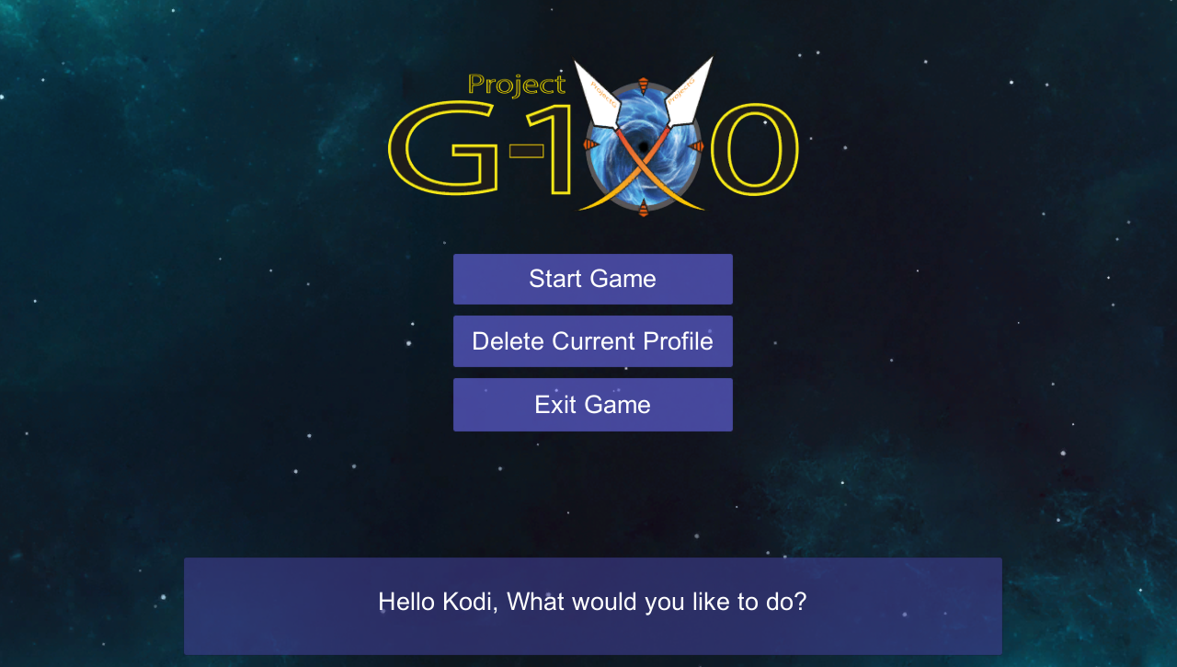 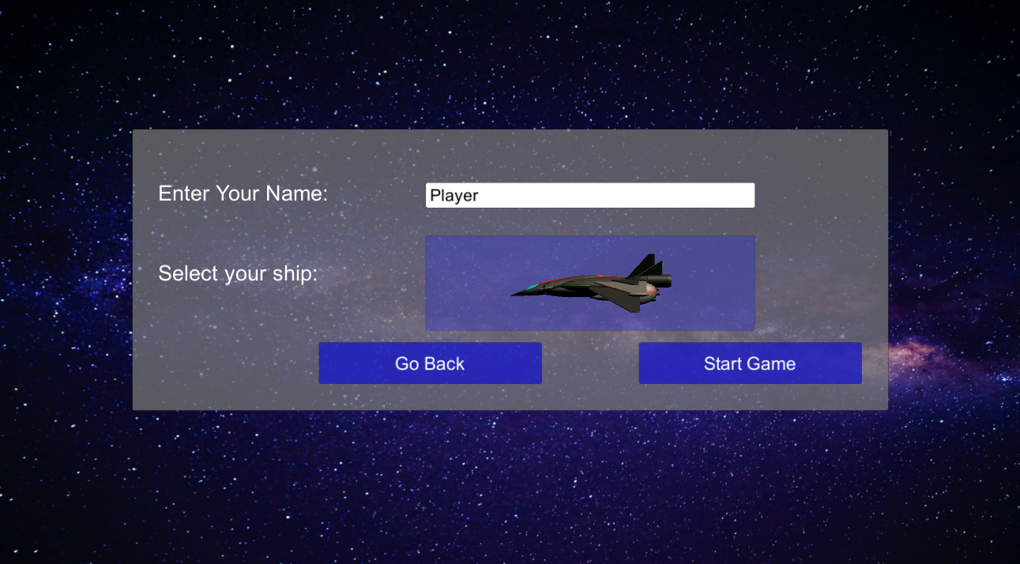

We have decided that this menu was looking good but was still lacking in design and features and so we planned to expand it. During one of our group meetings, we talked about what features we would require in the menu and so we expanded on it. Next menu version still had the same look but now featured more options. The menu would detect if a profile existed, if not, would only allow to create a profile or exit game. Once a profile was created (by entering a user name), it would be saved locally and allow player to choose from options such as, “Start Game”, “Display Profile”, “Delete Profile”, “Lottery System”, “Leaderboards”, “Lottery System”, “Settings” and “Exit Game”. Each option would display a different screen depending on the content, for example, “Start Game” would bring player to choosing ship and later on, choosing power up engine for use in game. This version of menu looked as such:

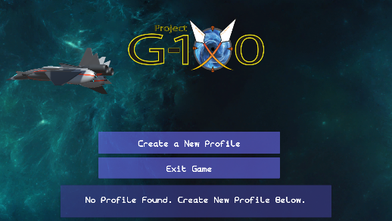 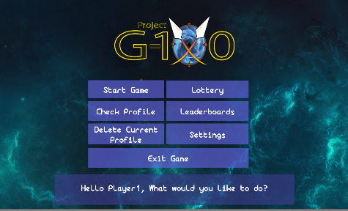 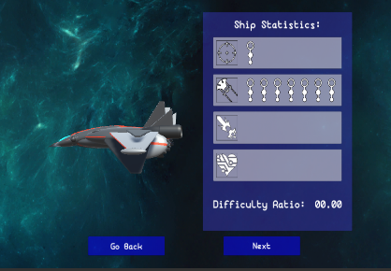

We felt that the menu was much more sophisticated by now but still lacked certain aspect of immenseness and so we felt there was room for improvement. We have further expanded on it and decided to create the menu in Ship Hangar. The hangar was created in Maya LT and placed into Unity. Each different display unit inside of the hangar would correspond to different feature of menu system and camera would move around depending on option selected. This resulted in a good looking and immersive menu that allowed us to give the menu more life as well as improve on User Experience part of it. The menu in 3D ended up with much better UX and gave us option to create animations to immerse the player into the game before they would even start playing properly. Below are the pictures of different parts of menu followed by description of functionality:

The whole menu system consists of seven different main options to choose from, as well as two possible states, No Profile and Profile found:

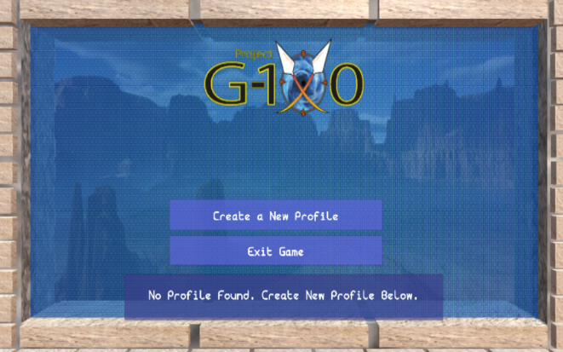 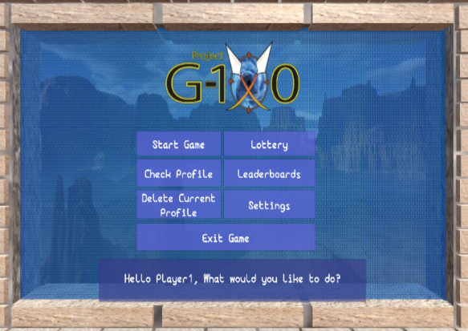

After clicking, start game player is greeted by a rotating ship, which they can preview, and its statistics: Damage, Fire Rate, Speed, Health of the ship. Player can change ships by using arrow keys left and right.

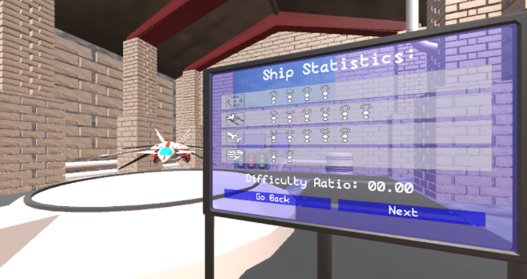

After pressing “Next” player is sent to Engines Select Screen, which allows them to choose the engine that they’ll use in game. Each engine has three different power-ups as well as different character tied to them, which will react to different states throughout gameplay. Player can also choose a power-up to see what each power up does for each engine. After pressing “Start Game”, the player is taken straight into game.

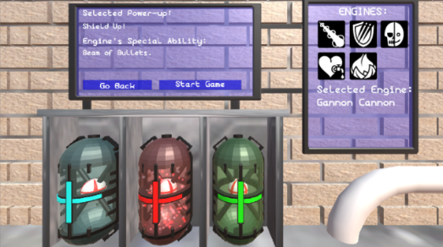

There are other features of menu as well, such as Gacha Menu. This allows player to use the crystals they have earned by clearing the level to Power on a Generator which opens up a “Portal” for a random faction to send over a new ship or engine to help the player progress.

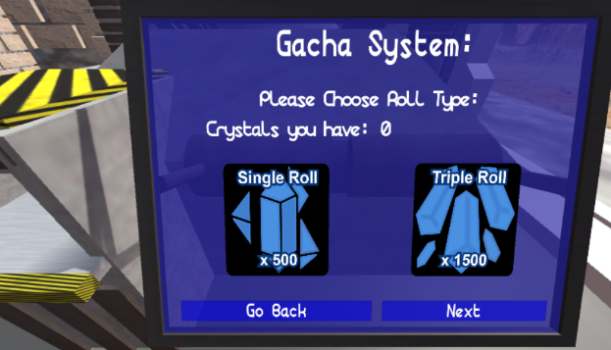

Player can also view the Leaderboards screen to see how he compares with other players (Other locally stored profiles) on different levels.

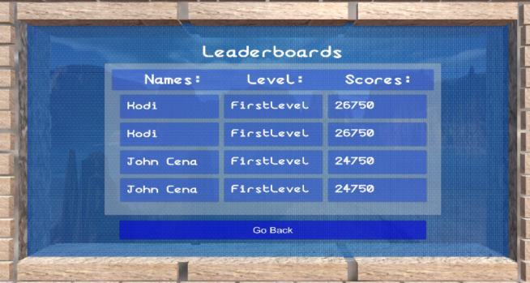

The player can also go to Settings Menu to adjust different settings in order to suit their machine and improve performance of the game.

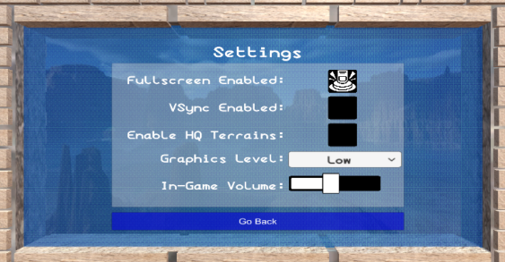

The Display Profile screen consists of different information about user’s gameplay profile. It displays statistics of player’s progress on different aspects of game. If the arrow pointing to right is pressed, player is brought to the Inventory Screen.

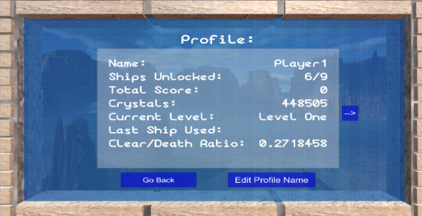

The Inventory screen is a museum of ships that player can use to learn more about each ship they have unlocked as well as preview the ship up closer and turn it right and left by using left/right arrow keys.

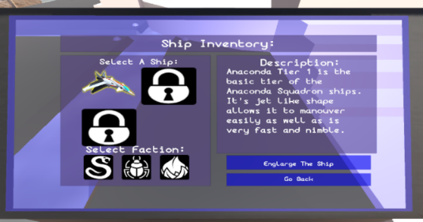 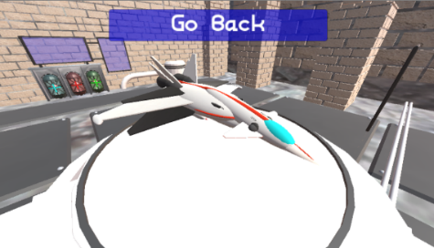

## 4.3 In-Game HUD

The HUD is labeled using numbers 1-5 to describe what each function does.

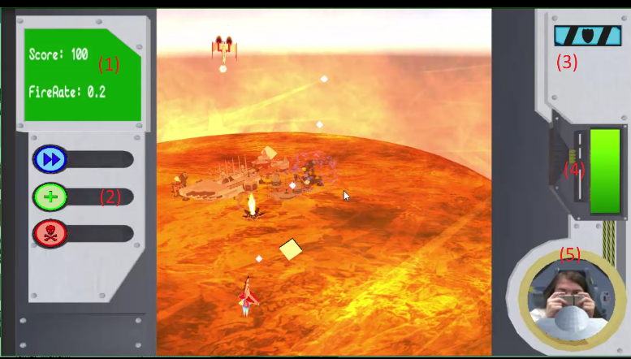

1. The statistic display screen. Shows score that player has got and current fire rate of their ship.
2. Decoration piece to not leave the HUD empty. Was intended first to interact with power-ups but lost its purpose over course of creating the game.
3. Health display. shows how much Health the ship still has.
4. Special Ability Charge Meter. This meter charges up as player is shooting and when full allows to release a special ability that player’s engine has, if possible. (Konrad Cheat-Death Contraption’s ability is to respawn on death, basically giving another chance to try the level without losing progress.)
5. Engine’s character animation portrait that displays different reactions based on what happens in game. If player gets hit, the character reacts to that, if player is not hit for 20 seconds, a special animation is shown, if entering boss fight, character also reacts to that as well as other reactions.

## 4.3 World Design

Working on the world design, we were discussing ways of making the levels in a lore way. As we did not want levels to be made up from nowhere and decided to develop them in such a way so that we could tell a story through the design. The game plays as home planet of player is under sudden attack and you have to fight back and repel the invaders.

Level one starts on the home planet and player is a military person what means he would start form a location that is not really exposed and is far away from colonized locations. This was made in our mind by looking up real life military bases around the world and they are located far away from urban location, so we decided to locate the first level in a middle on nowhere. This also was a strategic idea, this is because there is not much going on in the level making the player focus on the mechanics of the game. We were making the level in Unity, using the terrain tool and building it in it making it a good way to start of as it was the very first level and we were not the experienced in using it so it ended up good for both player and us. As it is in the middle of nowhere player will see trees, hills and nothing special, and as this is a earth like planet it should look like something we already know.

Level two on other hand is a totally different scope. This level is where player fights back and repels the enemy forces back to planet orbit and takes fight there. Here the player will see their invasion forces flying around and you will see a massive mother ships floating in the background. The idea here was to bring a new biome of sort to the game and logically the planets orbit was an ideal way. Here the level is totally different, seeing objects floating in space, satellite and forces and we wanted to give the player that WOW feeling. The development process of this level was to make the level look 1st different form level one and 2nd interesting providing the new look at the idea of space shooter.

Level three was another jump to a totally different biome again and here we wanted again something that makes sense so repel the forces even back to the point they gather energy. And the place to collect energy that would make sense would need to be the sun. This thinking process which leaded us here. For this level we wanted it to look immersive and different, so the sun surface was a good idea for us. Making a sun surface came at a cost of time but the end results it totally worth it. As the gameplay takes place on the sun it needs to be atmospheric and we decided to optimize it by having everything under energetic shield which blocks harmful effect of the sun so the combat and makes sense here. The process here was to make, sun surface followed my defences then by mines then by pipes and finally by placing all assets together.

## 4.4 Game Rendering

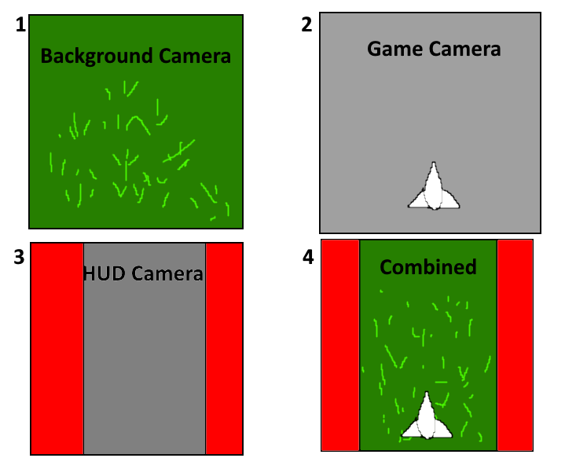One of the most important parts of making our game work correctly was the use of render textures and multiple cameras in order to render the game the way we wanted. Once we had the first two levels completed, it was clear something had to be done to make sure the player and enemies didn’t ‘clip’ through the terrain and background objects in the level. It was while developing the camera scrolling for the second level that we found the magic that was render textures.

A rough explanation of the render features.

In order to make the cameras work correctly, everything was sorted out into separate layers so that unity’s culling mask would know what to capture and what to hide.

The Background Camera contains everything the player is not meant to interact with in the level. Basically, this is the scenery.

The Game camera contained every object the player would have to interact with, as well as a “Render Plane” which was given the render texture of the background camera. This was to avoid ghosting issues we had when leaving the game camera without a background.

The HUD camera was there so that Unity would have a game screen to render to. Attached to this camera was a UI canvas containing the HUD, as well as a raw image to display the game camera texture. This left us with the final result here which looks almost seamless.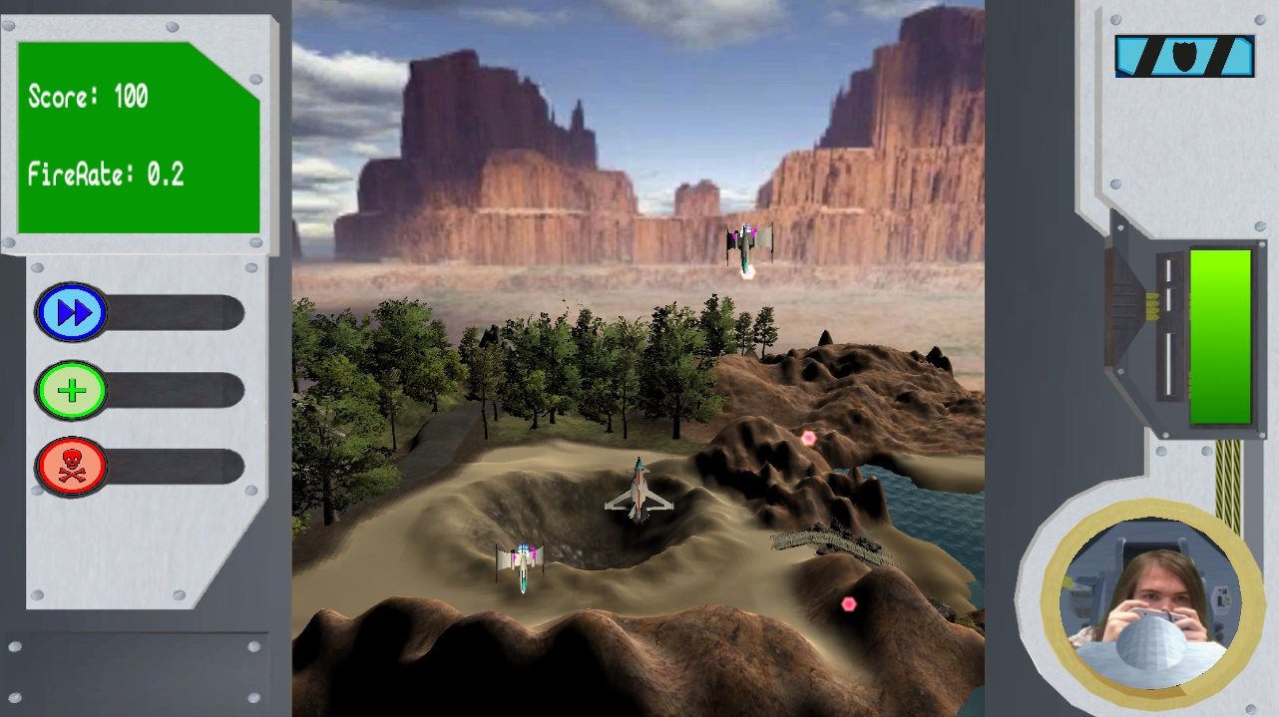

# 4.5 Ship Design

Once we had finalized the three factions we wished to implement into the game, our head modeler went to work with several prototypes for the ships to be used in game. In terms of the gacha, we decided the Cebula Knights would be a “Legendary” drop and thus were given their Medieval-esque designs. The ship models and their inspirations are shown here:

**The First Anaconda ship (VC21-Eagle)**

This ship was based off a number air and space craft, it is a combination of an RAF typhoon, an ARC-170 (Star Wars) and the H8 Global Defender (Independence Day 2).

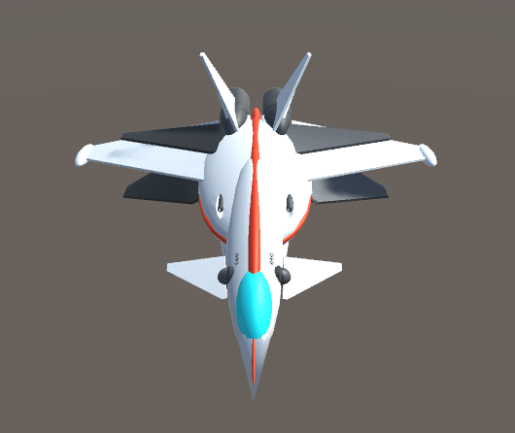

**The Second Anaconda Ship (AF44-SpaceHawk)**

The TG44-SpaceHawk a fighter design is a combination of the F-14 and F-302 (Stargate SG-1) giving the ship a bigger shape

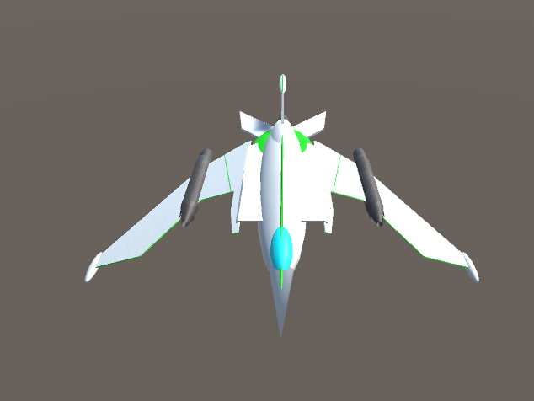

.

**The Third Anaconda Ship (MvF-Raptor)**

The MvF-Raptor is a thin nimble ship with its design based off a C-20 Gulfstream and sharp angled wings of an F-14.

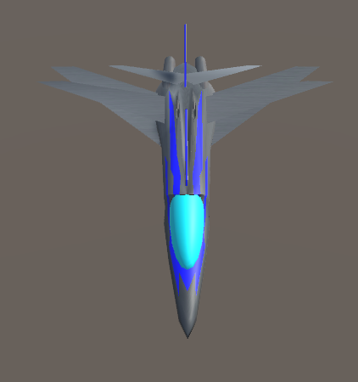

**The First Scarab Ship (TAS-Wedge)**

The TAS-Wedge is a large fighter craft designed by combining a Jedi Starfighter (Star Wars ep.3), the weapon system of a Deimos Pattern Whirlwind Scorpius(Warhammer 30K/40K), and a lot armour plating.

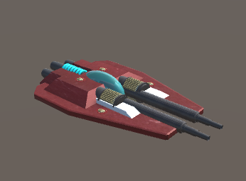

**The Second Scarab Ship (Railclass-Lance)**

The Railclass-Lance is a large fighter with similar design to the TAS-Wedge, the TAS-Wedge had is primary weapons replaced with railguns and given more armour.

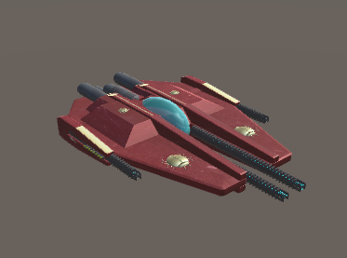

**The Third Scarab Ship (BFS-Flying Slab)**

The BFS-Flying Slab the largest of all the player ships, its design was based around a quote for one of the team members “Give me brick with engines”, this lead to a large blocky ship that was based somewhat off a Land Raider tank (Warhammer 30K/40K).

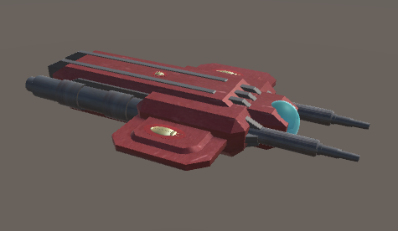

**The First Cebula Ship (The Divinity blade)**

The Divinity Blade is a European long sword that has been fused with a railgun and given a single space thruster.

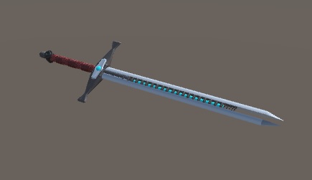

**The Second Cebula Ship (The Bolt Sword)**

The Bolt Sword is a European War Sword that has had its guard replaced with two machine guns. The sword and its design is based off of the swords used by the custodes(Warhammer 30K/40K).

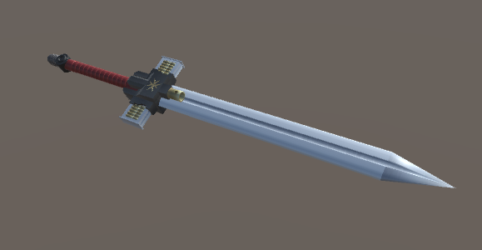

**The Third Cebula Ship (The RF-CrossBow)**

The RF-Crossbow is a crossbow that has its bolt firing mechanism replaced with a laser blaster, the design was influenced by the crossbow from Van Helsing Vampire Hunter. 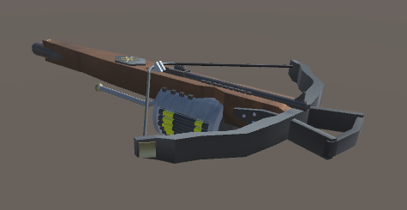

# Chapter 5 – Time Management

## 2.1 Weekly Meetings

We followed the agile project management principles throughout our projects. We also had weekly meetings at least twice a week, for which I always made sure to book rooms in library well in advance as well as small quick meetings in our own times during or after college hours. We had a private meeting in the beginning of the week to discuss our current progress, what we’ve done and what we are planning to work on next, any feedback towards the project, as well as any problems we’ve faced during our work. Towards end of the week, we’d have a meeting with our supervisor to display our current progress and work on the project. We’d all talk individually what we’ve managed to get done up to date and then as team we’d discuss what is done well, give feedback, what needs to be done next and finally we’d listen to our supervisor for any advice on what should be done next and how long we should spend on different stages of the project.

## 2.2 Time Distribution

Overall, the time was very strict on us in terms of projects we had. To be able to successfully complete this project, we had to organize our time effectively. We always held at least two meetings a week to discuss the progress on the project. Usually in the beginning of the week we held our own meeting which was followed nearing the end of the week by a meeting with our supervisor to allow us to display our current status of work, receive feedback on what we’ve done and planned to do next and then for any questions in case we required more insight into our current work. This kind of time management allowed our project to progress in a very steady and effective pace. We’ve usually dedicated weekends which were before meetings, day before later meeting with mentor and sometimes more time to work on the project. This organized work-time patterns meant we always were available to work together on the project and help each other out if any member of team has any major trouble with their current work and so any issues were sorted out very quickly.

# Chapter 6 – Problems Encountered

## 6.1 Cleaning out the game

Our first major problem occurred when trying to re-create the game in the very beginning. Due to the fact that we were yet unfamiliar with Unity 3D as it was our first time using this engine, we had created a very unclean and bloated up version of game and so we decided to recreate the base game in a new project and clean up whatever needed to be. However, due to lack of skills with Unity, this task turned out to be very time consuming and created a good amount of incompatibility errors. Thanks to good teamwork and cooperation, we worked together to quickly overcome that. In process of that, we’ve discovered that the Health System and Damage system codes were over complicated and we’ve worked together to simplify it and make it more modular with the basic functionality as before. This provided us with collision and health code that worked universally for any object, be it player, obstacle, enemy ship or even boss.

## 6.2 Merging the two versions of game

Our major problem was the fact the we made the game in a bit of a problematic way. Each member had their own version and worked on their own features of the game separately. This meant that in the end we had to merge the two version together. This turned out to be more problematic that we’ve initially planned as it created bugs and glitches inside Unity Project (Missing textures, wrongly preset prefabs etc.). As we were cooperating a lot during that process, this meant the merge took much less time that it could and we were very quickly back on track.

## 6.3 Maya

While working on Maya in year 2, we learned only a small amount on how to model correctly. The main problems we encountered here were to do with polygon counts and texture exporting.

We encountered so problems with the polygon count of certain models, some models had over 1,000,000 polygons, we had to find a way to take all these objects and merge them into one. After looking at a few tutorials we could merge large numbers of polygons together reducing the overall polygon count which helped improve game performance.

While working on the models we wanted to texture them so they would look more realistic as well as not plastic. When models were ready to texture we had a major problem with texturing it, because we did not do enough of it in year 2. This was a major problem for a few weeks as we had no idea how to export textures or apply them correctly.

When models were done and textured another big problem we came across was exporting the files to Unity. This was a major problem before we fixed them the models would end up black, mis-textured or not textured at all. This was a big setback, due to this problem the models needed to be constantly re worked and textured reapplied until we finally figured a way to do it so it holds itself together and does not break while at the same time move them from one team member to another to implement inside the level or as usable ships.

## 6.4 Unity scene planner

There were a good few problems here, as we were working on making the levels, we used the Unity scene planer to place objects and make the level.

While this was our first encounter on making terrain, we needed to learn its mechanics, so this was the first problem. Lack of knowledge of making terrain and placing objects on it was the main cause of the first level taking much too long to complete. When the first level was gaining shape, it was decided that the level was too small, and we found out that terrain in Unity cannot be scaled correctly.

It was decided that we would have to remake the terrain. After the level was redone it took another long time to make the level from zero again and implement everything back. However, then we discovered terrain could not be rotated which caused the entire level to be deleted and redone again. During this time we decided to make the terrain as one large mass instead of the sections we had planned before, but this led to serious performance issues thanks to the amount of trees present on the map as well as our previous method of moving through the level which was to..well..move the terrain itself. This was where we developed the new camera.

After being in progress of working on the level two we totally overhauled the camera system which open much more options but forced to redo level two and due to the new camera level 1 broke and needed to be fix

## 6.5 Unity particle system

Problem encountered here not that problematic. here the biggest problem was to figure how to make particles go in a circle, rotate over lifetime and make them move towards a specific point but due to messing around these were solved easily.

## 6.6 Miscommunication

Throughout the course of the project development, one of our larger problems was occasional miscommunication or lack of between members of the team on certain parts. There were times when scripts were changed and assets completely changed when swapping between different versions of the same levels leading to unnecessary bulking of the project size. As well as this, models were given textures in different folder names between those same versions. An example of this is written above with the camera system where a new version was created which wasn’t known until the second level was already fully completed.

However, these issues did not impair our progress much and were more slight annoyances.

# Chapter 7 – Results

## 7.1 Levels

At the very end of which we are here we are extremely happy with the levels we have created. All of them are unique, provide different atmosphere and makes the game feel progressive. At the very end the levels provided are good for us.

## 7.2 Final Game

Looking at the game in its first days and looking at it now, we have achieved a tremendous amount of changes and work. The game is packed with different features, has all the important parts we’ve planned to implement and is polished off. It took a lot of good teamwork, patience, cooperation, organization and hard work to come this far but we’re not only improved our teamwork but learned a lot of new skills that we’ll be able to apply in our future careers. Our first version of project had only one default ship with very basic score system, few obstacles to fight through, hard coded wave system transformed into a game with fully 3D menu system, lottery system, local file storage, sophisticated wave system that allows us to set waves through editor without any difficulty whatsoever, amazing looking ships, a 3D HUD design that features character animations based on engine chosen, fully 3D environment while playing through level, unique boss fights to play through and many ways to play through those levels using different ships and power up engines. Overall, we think the project was a fun, challenging and also a learning experience that provided us with real-world scenarios and workflow of a real team-based project that we’d do in a real company.

## 7.3 Models/Assets

We were very happy with the final result for the models developed. The first versions of the models were good, but they didn’t look very aesthetically pleasing with their current textures. After the texturing was correctly applied the models had a more realistic and detailed look. People we demo’d the game to all gave strong praise for the ship models and environments.

## 7.4 Growth

We would all agree that we’ve learned a lot more skills around game development thanks to this project. Our artists now have an even better grip on Maya than previously, and our programmers can now say they have a Unity game under their belts which should hopefully lead to more and better games in the future. As for the game itself we’re in the process of adding a system to allow us to add regular updates such as new ships, powerups and levels.

# Chapter 8 – References & Appendices

# Bibliography

|  |  |
| --- | --- |
| [1] | Renatus, "Gacha: Types of Japanese monetization mechanic," Renatus Media LLC, 14 02 2017. [Online]. Available: http://renatus.com/gacha-types-of-gotcha. [Accessed 2017 11 07]. |
| [2] | Epic Games, "Frequently Asked Questions (FAQ)," Epic Games, 2017. [Online]. Available: https://www.unrealengine.com/en-US/faq. [Accessed 07 11 2017]. |
| [3] | Epic Games, "Blueprints Visual Scripting," Epic Games, 2017. [Online]. Available: https://docs.unrealengine.com/latest/INT/Engine/Blueprints/. [Accessed 2017 11 07]. |
| [4] | Unity, "Unity - Fast Facts," Unity Technology, 2017. [Online]. Available: https://unity3d.com/public-relations. [Accessed 07 11 2017]. |
| [5] | Creative Bloq Staff, "How to texture a model in Maya," 9 12 2013. [Online]. Available: https://www.creativebloq.com/3d/how-texture-model-maya-121310050. |
| [6] | Unity, "Manual: Importing Objects From Maya," Unity, 2017. [Online]. Available: https://docs.Unity3d.com/Manual/HOWTO-ImportObjectMaya.html. [Accessed 2018]. |